**Eid-al-Adha, the second of two religious holidays celebrated by Muslims worldwide each year, is an Islamic festival to remember Ibrahim's willingness to sacrifice his son to God. It is observed around the 10th to the 13th days of the Islamic month of Dhu al-Hijjah.**

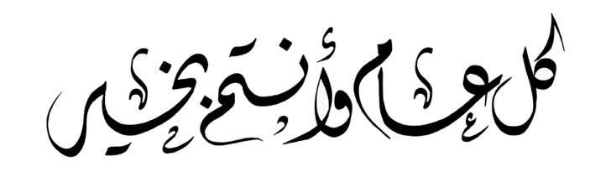

**Eid-al-Adha, the second of two religious holidays celebrated by Muslims worldwide each year, is an Islamic festival to remember Ibrahim's willingness to sacrifice his son to God. It is observed around the 10th to the 13th days of the Islamic month of Dhu al-Hijjah.**



**Eid-al-Adha, the second of two religious holidays celebrated by Muslims worldwide each year, is an Islamic festival to remember Ibrahim's willingness to sacrifice his son to God. It is observed around the 10th to the 13th days of the Islamic month of Dhu al-Hijjah.**



**Eid-al-Adha, the second of two religious holidays celebrated by Muslims worldwide each year, is an Islamic festival to remember Ibrahim's willingness to sacrifice his son to God. It is observed around the 10th to the 13th days of the Islamic month of Dhu al-Hijjah.**



**Eid-al-Adha, the second of two religious holidays celebrated by Muslims worldwide each year, is an Islamic festival to remember Ibrahim's willingness to sacrifice his son to God. It is observed around the 10th to the 13th days of the Islamic month of Dhu al-Hijjah.**



**Eid-al-Adha, the second of two religious holidays celebrated by Muslims worldwide each year, is an Islamic festival to remember Ibrahim's willingness to sacrifice his son to God. It is observed around the 10th to the 13th days of the Islamic month of Dhu al-Hijjah.**

